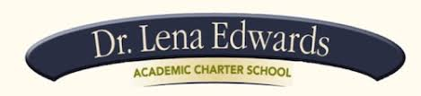

Greetings Families

April 17, 2018

RE: PARCC Testing Schedule Spring 2018

This memo is to inform you that the PARCC assessment window opened on April 16, 2018 and closes on May 25, 2018. DLEACS students (Grades 3 to 8) will start the PARCC testing this Monday, April 23 and end on Friday, May 11, 2018.

This memo also includes the following:
- The number of units (ELA/L & Math) tested
- Time allotted for each unit (with the exception of students who have IEPs or have special 504 accommodations for medical or physical limitations)

FYI
- Our students will take the computer-based test (CBT).
- Please ensure that your child arrives to school by 8:15 AM
- All cell phones (apple/android watches) and other electronic devices must be turned in before testing begins
- The statewide assessment schedule for the 2017 – 2018 administration is on the reverse side of this memo.

Parent Resources for PARCC:

http://www.nj.gov/education/assessment/parents/

Thank you
Principal Brewer

